İçindekiler

İçindekiler 1

Figures 1

Linux Plus 2

Basic User Commands 5

User Management 6

User Passwords 7

Group Management 7

Package Managements 8

DPKG – Debian Package Management System-1 8

RPM (Red Hat Package Manager) 9

Filters 10

Control Operators 10

Bash Shell Scripting 11

Interview Q&A 12

ODEV 14

# Figures

Figure 1 The File Types. 2

Figure 2 Color Files Types. 2

Figure 3 File History. 3

Figure 4 Grep Command. 3

Figure 5 Vim. 4

Figure 6 Nano. 4

Figure 7 ssh Command. 5

Figure 8 Sudo Command 5

# Linux Plus

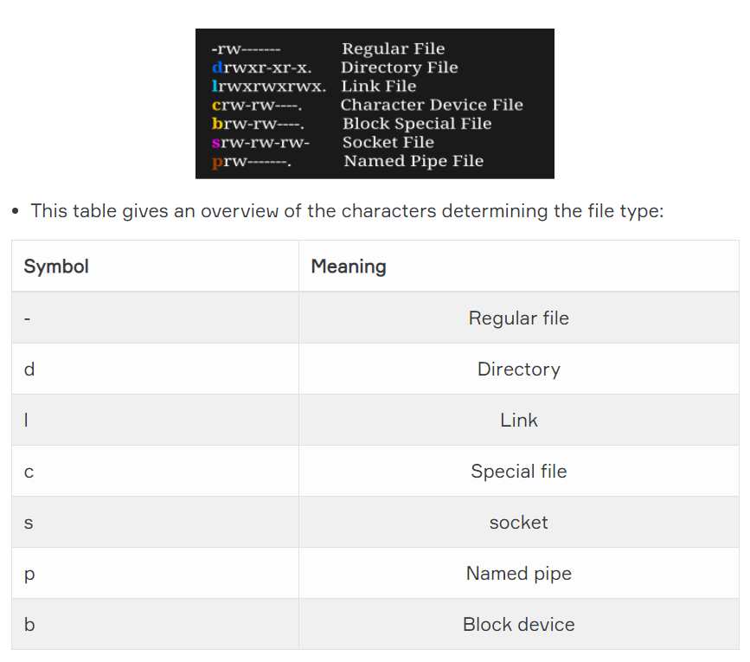

Figure 1 The File Types.

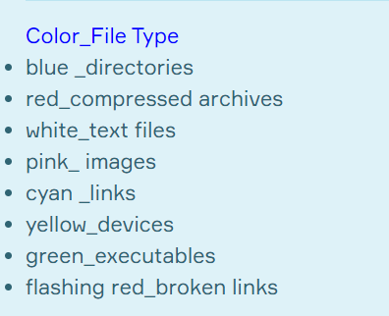

Figure 2 Color Files Types.

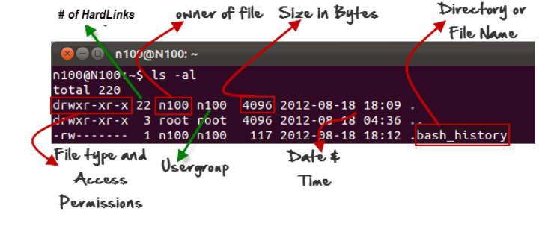

Figure 3 File History.

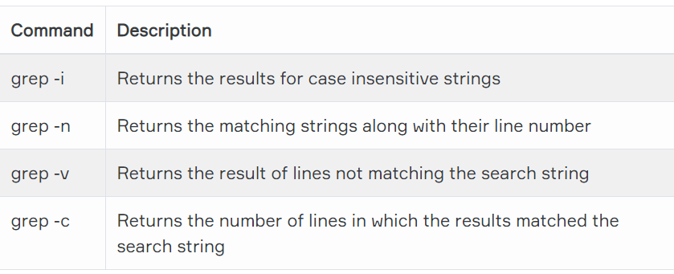

Figure 4 Grep Command.

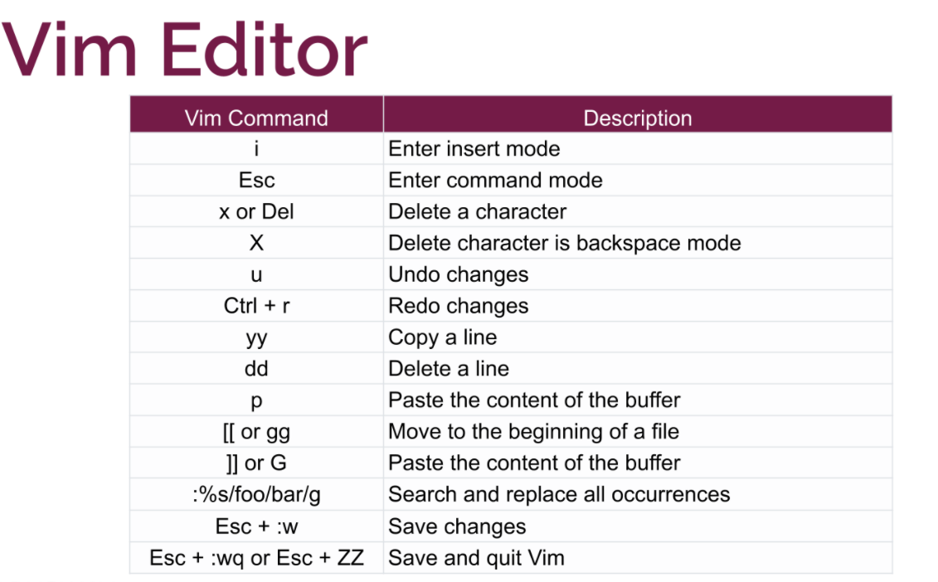

Figure 5 Vim.

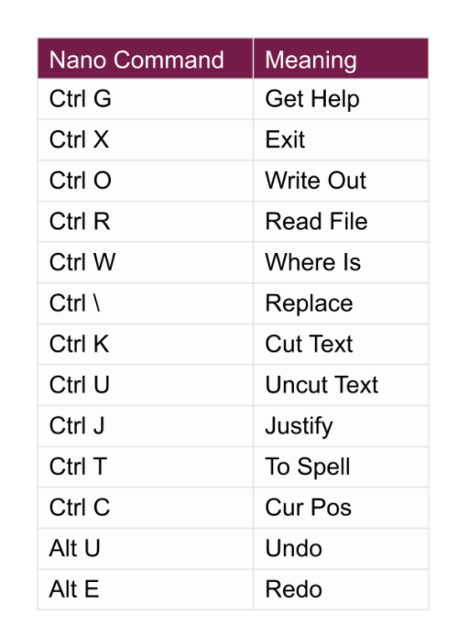

Figure 6 Nano.

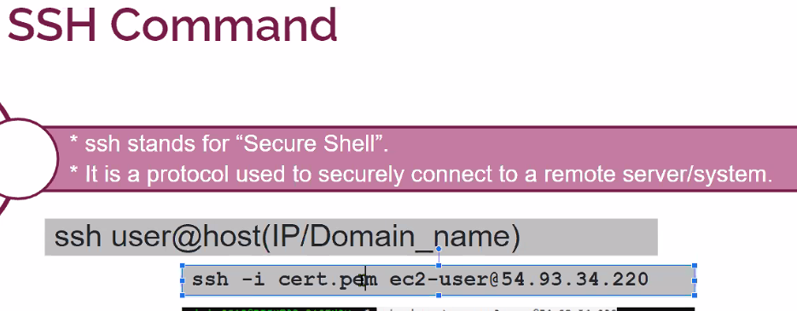

Figure 7 ssh Command.

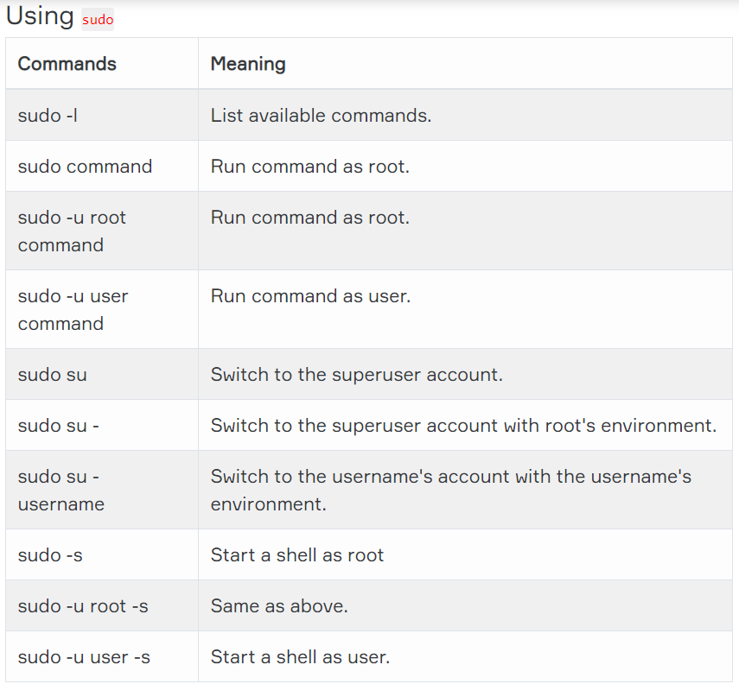

Figure 8 Sudo Command

## Basic User Commands

1. Whoami

Your username is indicated by the whoami command.

1. who

The who command will provide you with details about who is logged on the system.

1. who am i

who am i the who command will only show the line that points to your current session.

1. w

The w command will inform you who is logged on and what they are doing.

1. id

The id command will provide your user id, your primary group id, and a list of the groups you belong to.

1. su

The su command enables a shell to be run as another user.

1. su -

The su command retains the same shell environment by default. To become another user and also get the environment of the target user, issue the su - command followed by the target username.

1. Su -

If su or su - is not provided with a username, the command assumes that root is the target.

1. sudo su

The root user does not have a password set on some Linux systems like Ubuntu and Xubuntu. On these Linux systems, You can become root user via sudo su command.

User Management

1. /etc/passwd

On Linux, the local user database is /etc/passwd.

1. root

The most powerful account on your Linux system is the root user also called the superuser. This user is capable of doing almost everything, even creating other users. The userid of the root user   
is always 0.

1. useradd

useradd command is used for creating a new user. The following example shows how to add a user.

* -m is used for forcing the creation of the home directory
* -d is used for setting the name of the home directory
* -c is used for setting a description

useradd -m -d /home/E2193 -c "E2193 Account" E2193

1. adduser

adduser is not a standard Linux command. It’s basically a Perl script that uses the useradd command in the background. This is more effective at creating new users on Linux. Default parameters can also be set for all new users through the adduser command. You can walk through a series of questions by calling adduser with just a username.

adduser Umut

1. userdel

You can delete a user with userdel command. userdel command will not remove the user's home directory from the file system. If you want to remove the home directory, you need to use the-r in the command line.

userdel -r Umut

1. usermod

With the usermod command, you can modify a user's properties. This example uses usermod to modify the description of the user walter.

tail -1 /etc/passwd

usermod -c "AWS" E2193

tail -1 /etc/passwd

## User Passwords

1. passwd

User passwords can be set with the passwd command. Before entering the new one, users will have to provide their old password.

1. shadow file

User passwords are encrypted and stored in /etc / shadow file. The /etc/shadow file is only read and can be accessed by root only.

Sudo su –

tail -4 /etc/shadow

1. /etc/login.defs

The /etc/login.defs file includes some default user password settings, such as password aging and length settings.

grep ^PASS /etc/login.defs

## Group Management

1. groupadd

groupadd command is used to create a new group.

Sudo su –

groupadd linux

1. usermod

You can change group membership with the useradd or usermod command.

usermod -a -G linux james

1. Group File

Users can belong to several groups. Group membership is specified via the /etc/group file.

/home/clarusway# tail -3 /etc/group

* The first field is the group's name.
* The second field is the group's encrypted password.
* The third field is the group identification or GID (Group Identifier).
* The fourth field is the list of members.

1. groups

groups command is used to display a list of groups to which the user belongs.

john@DESKTOP-UN6T2ES:~$ groups

1. groupmod

groupmod command can be used to change the group name.

root@DESKTOP-UN6T2ES:~# groupmod -n ubuntu linux

root@DESKTOP-UN6T2ES:~# tail -3 /etc/group

1. groupdel

groupdel command is used to delete a group.

root@DESKTOP-UN6T2ES:~# groupdel ubuntu

1. gpasswd

With the gpasswd command, we can add a user to a group and to remove a user from a group. In the example below:

* We add john to aws group with gpasswd -a command.
* We remove walter from aws group with gpasswd -d command.

root@DESKTOP-UN6T2ES:~# gpasswd -a john aws

## Package Managements

### DPKG – Debian Package Management System-1

dpkg-deb --help

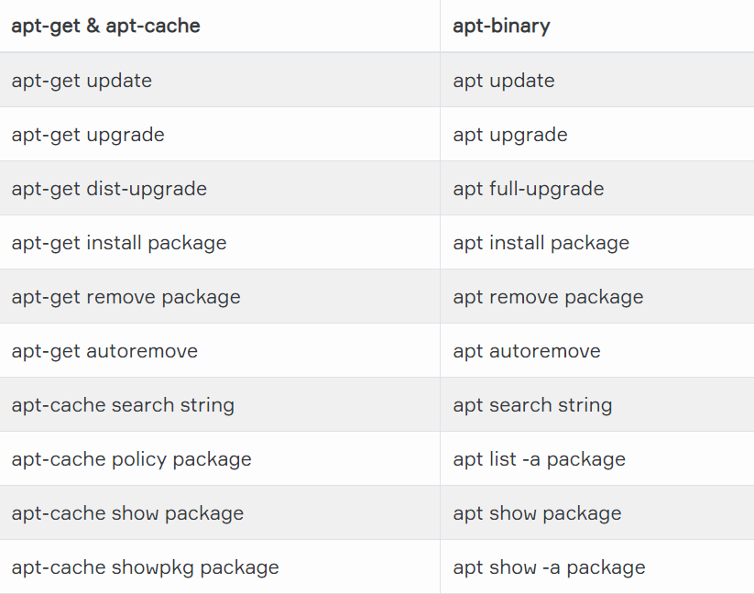

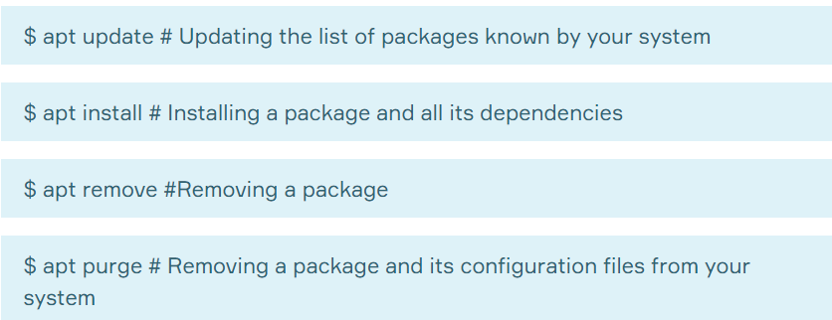

### RPM (Red Hat Package Manager)

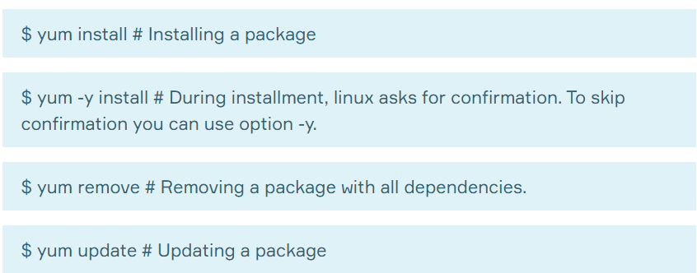

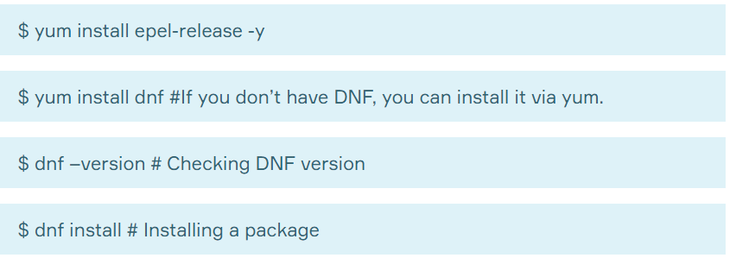

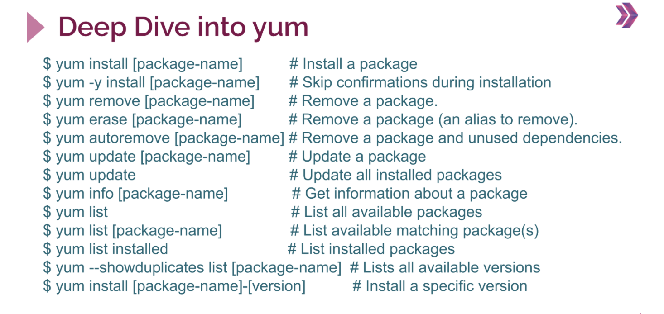

# Filters

# Control Operators

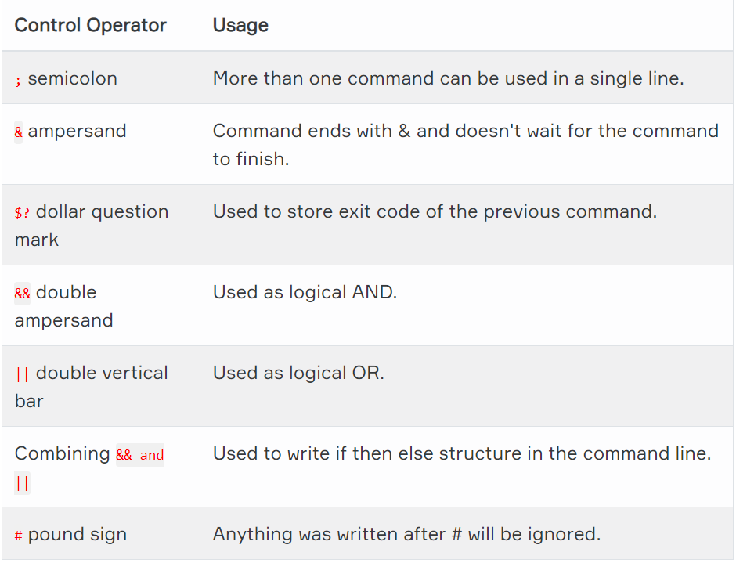

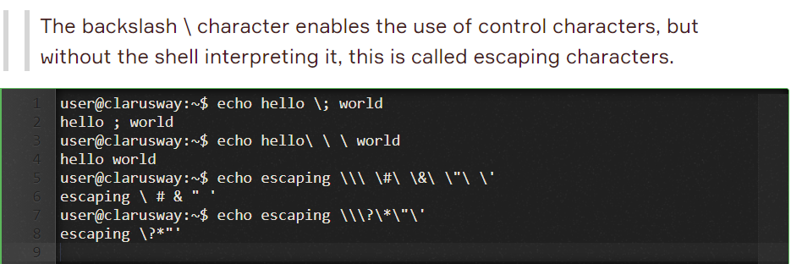

# Bash Shell Scripting

* export PS1="[\t \j] "
  + Displays time of day and number of running jobs
* export PS1="[\d][\u@\h \w] : "
  + Displays date, user name, host name and current working directory. Note that \W displays only base names of the present working directory.
* export PS1="{!} "
  + Displays history number for each command.
* export PS1="[\033[1;35m]\u@\h[\033[0m] "
  + Displays user@host in pink.
* export PS1="[\033[7;34m]\u@\h \w [\033[0m] "
  + White characters on a blue background.
* export PS1="[\033[3;35m]\u@\h \w [\033[0m]\a"
  + Pink prompt in a lighter font that alerts you when your commands have finished.

# Interview Q&A

Q: What does sudo mean?

A: sudo is an abbreviation of “super user do” and is a Linux command that allows programs to be executed as a super user (aka root user)

Q: how do you add a user to the sudo group

A: I should follow these steps:

* Log in to computer or server as the root user.
* Use the adduser command to add a new user to system. (#adduser username)
* Use the usermod command to add the user to the sudo group. (#usermod -aG sudo username)
* Test sudo access on new user account. (# su - username)

Q: What does package managers?

A: A package manager or package-management system is a collection of software tools that automates the process of installing, upgrading, configuring, and removing computer programs for a computer's operating system in a consistent manner.

Q: What is the difference between dpkg and aptitude/apt-get?

A: dpkg only installs a package, so doing dpkg -i packageName.deb will only install this Deb package, and will notify you of any dependencies that need to be installed, but it will not install them, and it will not configure the packageName.deb because well...the dependencies are not there.

apt-get is a Package Management System that handles the installation of Deb packages on Debian-based Linux distributions. A Package Management System is a set of tools that will help you install, remove, and change packages easily. So apt-get is like a clever dpkg.

Q: Why does the tee command used for?

A: The tee filter is used to send an output to more than one destination. It can send one copy of the output to a file and another to the screen (or some other program) if used with pipe (|)

Q: What is the difference between | and || in Linux?

A: A pipe (|) is a form of redirection (transfer of standard output to some other destination) that is used in Linux and other Unix-like operating systems to send the output of one command/program/process to another command/program/process for further processing.

But || is a logical OR operator. The second command is executed only when the first command fails.

Q: What is Shell?

A: The shell is the command interpreter in an operating system such as Unix or GNU/Linux, it is a program that executes other programs. It provides a computer user an interface to the Unix/GNU Linux system so that the user can run different commands or utilities/tools with some input data.

Q: Explain Linux file ownership.

A: Every Linux system have three types of owner:

* User: A user is the one who created the file. By default, whosoever, creates the file becomes the owner of the file. A user can create, delete, or modify the file.
* Group: A group can contain multiple users. All the users belonging to a group have same access permission for a file.
* Other: Any one who has access to the file other than user and group comes in the category of other. Other has neither created the file nor is a group member.

Q: How to change file permissions in linux?

A: I can change permissions from command line with chmod command. Read (r), write (w) and execute (x) are permission types that can be given to a file. You can also indicate these permissions with numeric mode. For example 777 gives full access permission (rwx).

# ODEV

